HW6 Solution

Problem 1
Assume that the gate delays are short compared to the input signal time scale.
- Sketch the waveforms that appear at the Q_{M} and Q_{S} outputs of the master and slave latches. Assume that the flip-flop is initially in the reset state.
- Do the waveforms exhibit any 1’s catching behavior? (1’s catching refers to the case where an unwanted transition on the input will force the output to an undesired state).
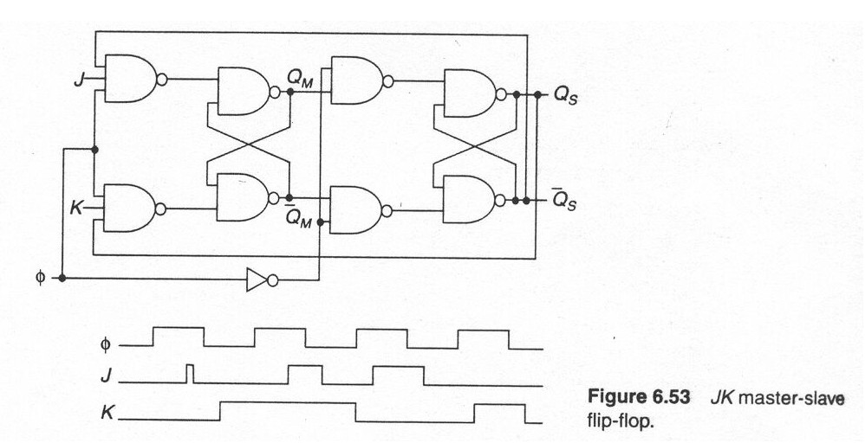
Solution:
(a)
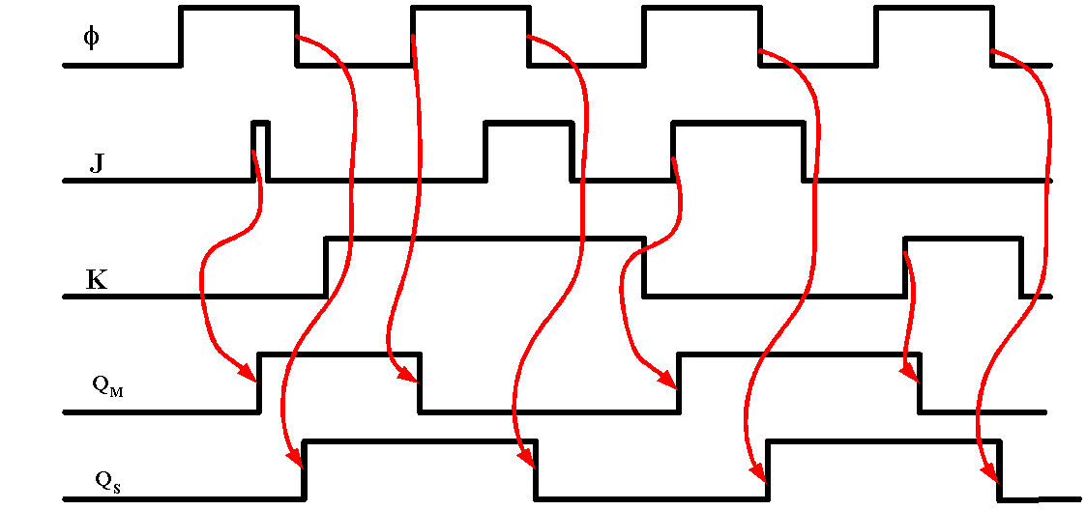

(b)
Yes, like in the figure above the glitch in J is caught. QM is set even though φJ returns to zero before the end of the φ cycle.

Problem 2
A dynamic master-slave D flip-flop is shown in the figure below. Assume that there is no charge leakage and that a nonoverlapping clock pair φ₁−φ₂ with 50% duty cycle is available. The sizes of all NMOS and PMOS transistors are 0.5 μm/0.25 μm and 1.0/0.25 μm, respectively. Assume V_{dd}= 2.5 V and C_{L} = 8 fF at the D output
- Provide a first order estimate of the parasitic capacitances at the inverter inputs
- Determine the set-up time and propagation delay of the register, and compare with SPICE.
M₁
M₂

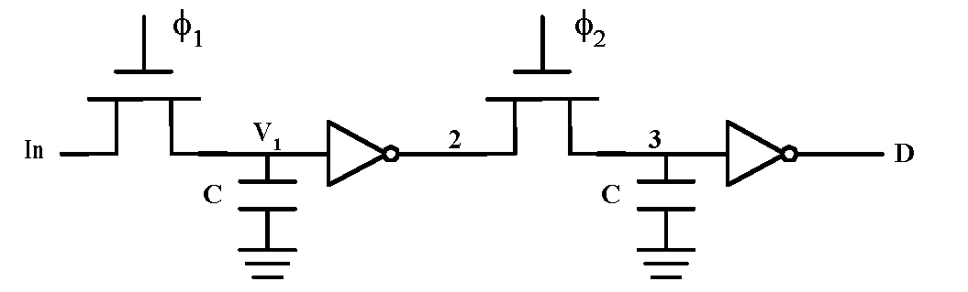

Solution:
(a)
Nodes 1 and 3 at the inputs of the 2 inverters are identical and experience the same total equivalent cap. Hence we only need to calculate the total cap at either 1 or 3. Now considering node1, here is a list of all caps that contribute to the total equivalent cap C at node 1:
- Four overlap caps in the inverters.
  - C₁ = 2*Con*Wn+2*Cop*Wp = 2*0.31*0.5+2*0.27*1 = 0.85 fF
- Two gate-channel caps at the input of inverter.
  - C₂ = C_{oxn}Wn*Ln + C_{oxp}Wp*Lp = 6*0.5*0.25 + 6*1*0.25 = 2.25 fF
- One overlap cap of M₁ between its gate and node 1.
  - C₃ = Con*Wn = 0.31*0.5 ≈ 0.15 fF
- One diffusion (junction) cap of M1.

Now, calculating the diffusion cap requires calculating the K_{eqH2L} and K_{eqL2H} for both bottom-plate and sidewall components. These parameters are caculated here:

L to H for NMOS M₁:
From page 195-196 of the book we have:
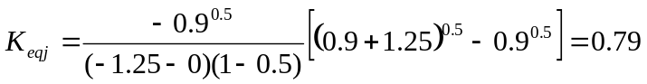

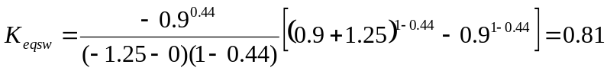

H to L for NMOS M₁:
We know that V₁ can not be larger than V_{DD}-V_{T}(_{VSB=V1}). Hence first we have to figure out the V_{T} and then the highest voltage on node 1.
Hence for H2L propagation time, V₁ has to change from 1.8V to 50% value of 1.25V.
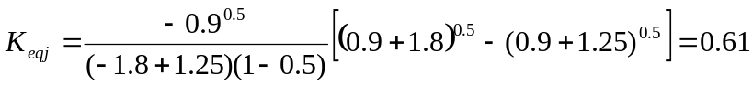

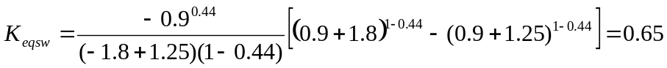

Now we can calculate total Capacitance at node1:
H to L
C₄ = K_{eq}*Wn*L_{D}*C_{j} + K_{eqSW}*(Wn+2L_{D})*C_{jSW} = 0.61*0.5*0.625*2+0.65*(0.5+2*0.625)*0.28 ≈ 0.7fF
C_{H2L} = C₁ + C₂ + C₃ + C₄ = 0.85+2.25+0.15+0.7= 3.95 fF

L to H
C₄ = K_{eq}*Wn*L_{D}*C_{j} + K_{eqSW}*(Wn+2L_{D})*C_{jSW} = 0.79*0.5*0.625*2+0.81*(0.5+2*0.625)*0.28 ≈ 0.9fF
C_{L2H} = C₁ + C₂ + C₃ + C₄ = 0.85+2.25+0.15+0.9= 4.15 fF

t_{setup} (setup time) is from In to node1:
H to L
0.69*(13/2)*3.95=17.7ps
L to H
0.69*(13/2)*4.15= 18.6ps
tp (propagation delay) is from node1 to D
For diffusion caps in the output of first Inverter we can use the Keq values in page 196 of the book.
L to H
Total cap at node2: (there are 2 N-type and 1 P-type diffusions plus one overlap plus 2 Miller overlaps)
2*(K_{eqn}*Wn*L_{D}*C_{jn} + K_{eqSWn}*(Wn+2L_{D})*C_{jSWn}) + K_{eqp}*Wp*L_{D}*C_{jp} + K_{eqSWp}*(Wp+2L_{D})*C_{jSWp}+ Con*Wn +2*(Con*Wn+Cop*Wp) = 1.78+1.05+0.72= 3.55 fF
Hence we have:
t_{pL2H} = 0.69*(13/2)*3.55+0.69*(13/2+13/2)*4.15+0.69*(31/4)*8 = 96 ps

H to L
Total cap at node2: (there are 2 N-type and 1 P-type diffusions plus one overlap plus 2 Miller overlaps)
2*(K_{eqn}*Wn*L_{D}*C_{jn} + K_{eqSWn}*(Wn+2L_{D})*C_{jSWn}) + K_{eqp}*Wp*L_{D}*C_{jp} + K_{eqSWp}*(Wp+2L_{D})*C_{jSWp}+ Con*Wn +2*(Con*Wn+Cop*Wp) = 1.34 +1.31+0.72= 3.37 fF
Hence we have:
t_{pH2L} = 0.69*(31/4)*3.37+0.69*(31/4+13/2)*4.15+0.69*(13/2)*8 = 95 ps

(b)Simulation results from PSpice

vdd vdd 0 2.5
vin in 0 DC 0 pulse(2.5 0 1.987n 0.5p 0.5p 2n 30n)
Vphi1 phi1 0 DC 0 pulse(0 2.5 0n 0.5p 0.5p 2n 4n)
Vphi2 phi2 0 DC 0 pulse(0 2.5 2n 0.5p 0.5p 2n 4n)

Msw1 in phi1 1 0 nmos L=0.25u W=0.5u AD=0.3125p AS=0.3125p PD=1.625u PS=1.625u
Mn1 2 1 0 0 nmos L=0.25u W=0.5u AD=0.3125p AS=0.3125p PD=1.625u PS=1.625u
Mp1 2 1 vdd vdd pmos L=0.25u W=1u AD=0.3125p AS=0.625p PD=2.25u PS=2.25u
Msw2 2 phi2 3 0 nmos L=0.25u W=0.5u AD=0.3125p AS=0.3125p PD=1.625u PS=1.625u
Mn2 D 3 0 0 nmos L=0.25u W=0.5u AD=0.3125p AS=0.3125p PD=1.625u PS=1.625u
Mp2 D 3 vdd vdd pmos L=0.25u W=1u AD=0.625p AS=0.625p PD=2.25u PS=2.25u

CL D 0 8f
.LIB C:\115c\025um_PSPICE_BSIM3.txt
.TRAN 0.01n 10n
.PROBE
.END

For H to L setup time: 14ps
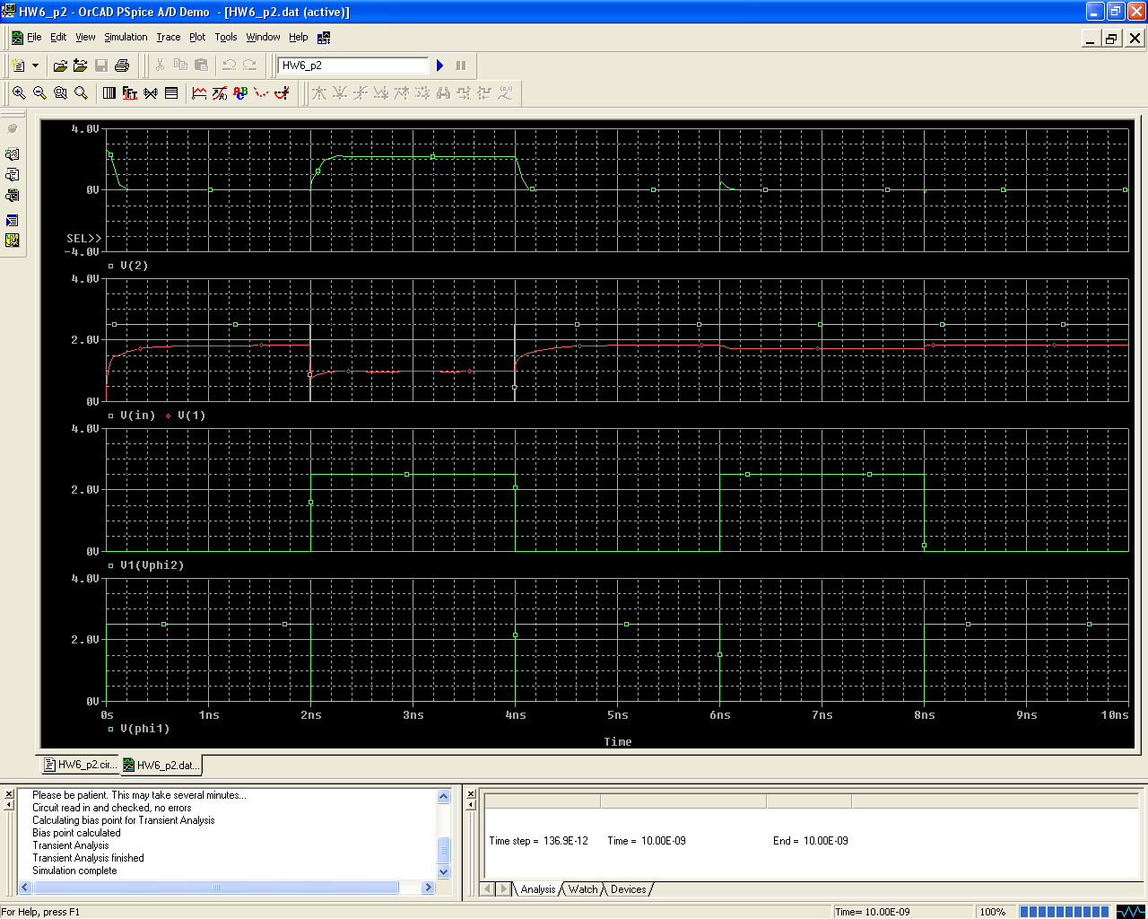

Zoomed in version:
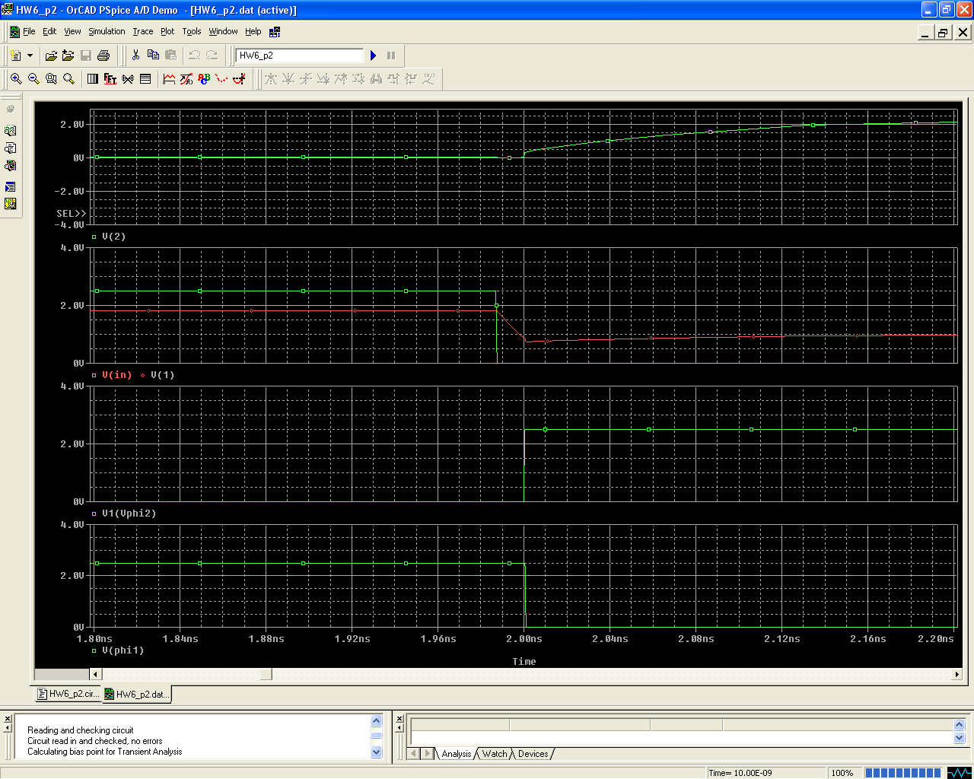

For L to H setup time: 70ps

vdd vdd 0 2.5
vin in 0 DC 0 pulse(0 2.5 1.94n 0.5p 0.5p 2n 30n)
Vphi1 phi1 0 DC 0 pulse(0 2.5 0n 0.5p 0.5p 2n 4n)
Vphi2 phi2 0 DC 0 pulse(0 2.5 2n 0.5p 0.5p 2n 4n)

Msw1 in phi1 1 0 nmos L=0.25u W=0.5u AD=0.3125p AS=0.3125p PD=1.625u PS=1.625u
Mn1 2 1 0 0 nmos L=0.25u W=0.5u AD=0.3125p AS=0.3125p PD=1.625u PS=1.625u
Mp1 2 1 vdd vdd pmos L=0.25u W=1u AD=0.3125p AS=0.625p PD=2.25u PS=2.25u
Msw2 2 phi2 3 0 nmos L=0.25u W=0.5u AD=0.3125p AS=0.3125p PD=1.625u PS=1.625u
Mn2 D 3 0 0 nmos L=0.25u W=0.5u AD=0.3125p AS=0.3125p PD=1.625u PS=1.625u
Mp2 D 3 vdd vdd pmos L=0.25u W=1u AD=0.625p AS=0.625p PD=2.25u PS=2.25u

CL D 0 8f
.LIB C:\115c\025um_PSPICE_BSIM3.txt
.TRAN 0.01n 10n
.PROBE
.END

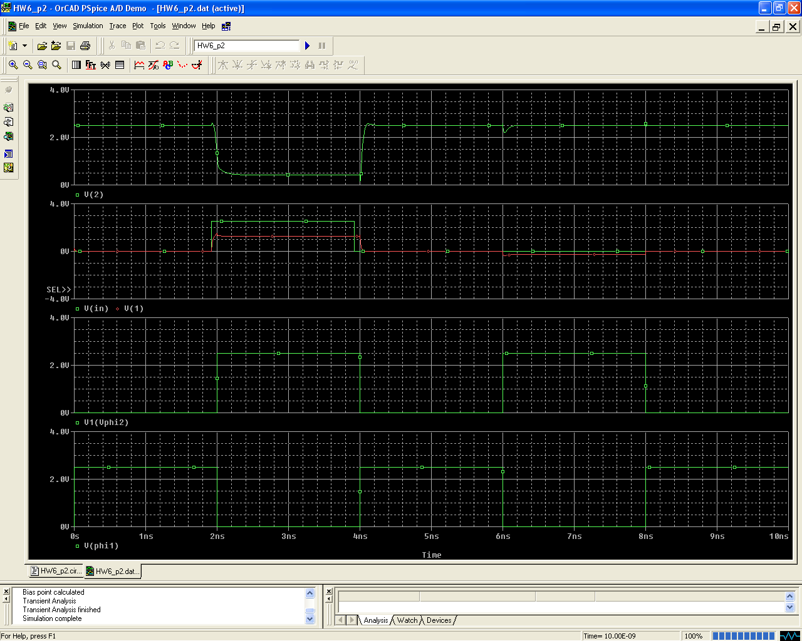

For tp H to L: ~190ps
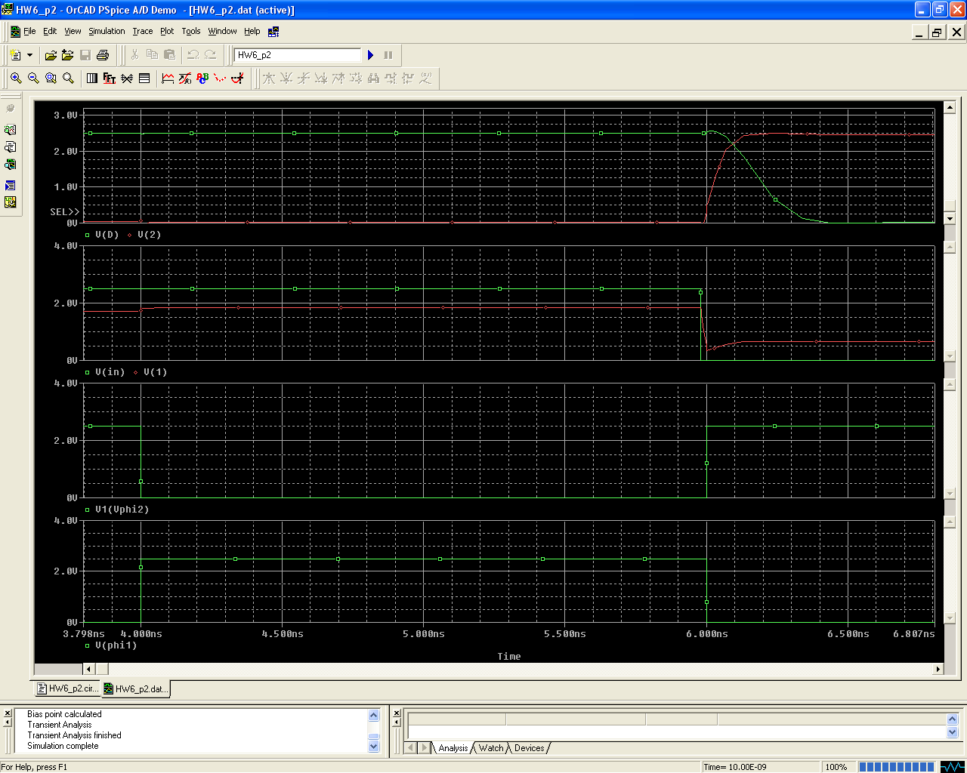

For tp L to H: ~200ps
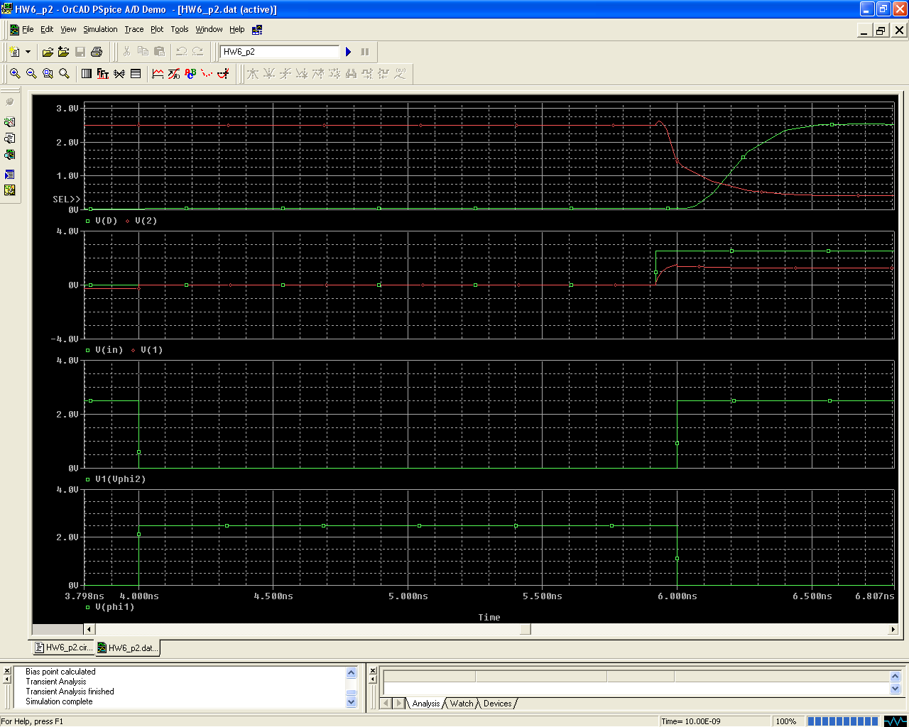

Problem 3
Pipeline the function 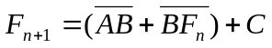with as many stages as possible. Include the input and output registers.
a) Design it at the gate level. Estimate the minimum clock period in terms of gate delays. Under what conditions can a race occur, assuming fast clock rise and fall times.

Solution:
(a)

We can implement the function by using TSPCR

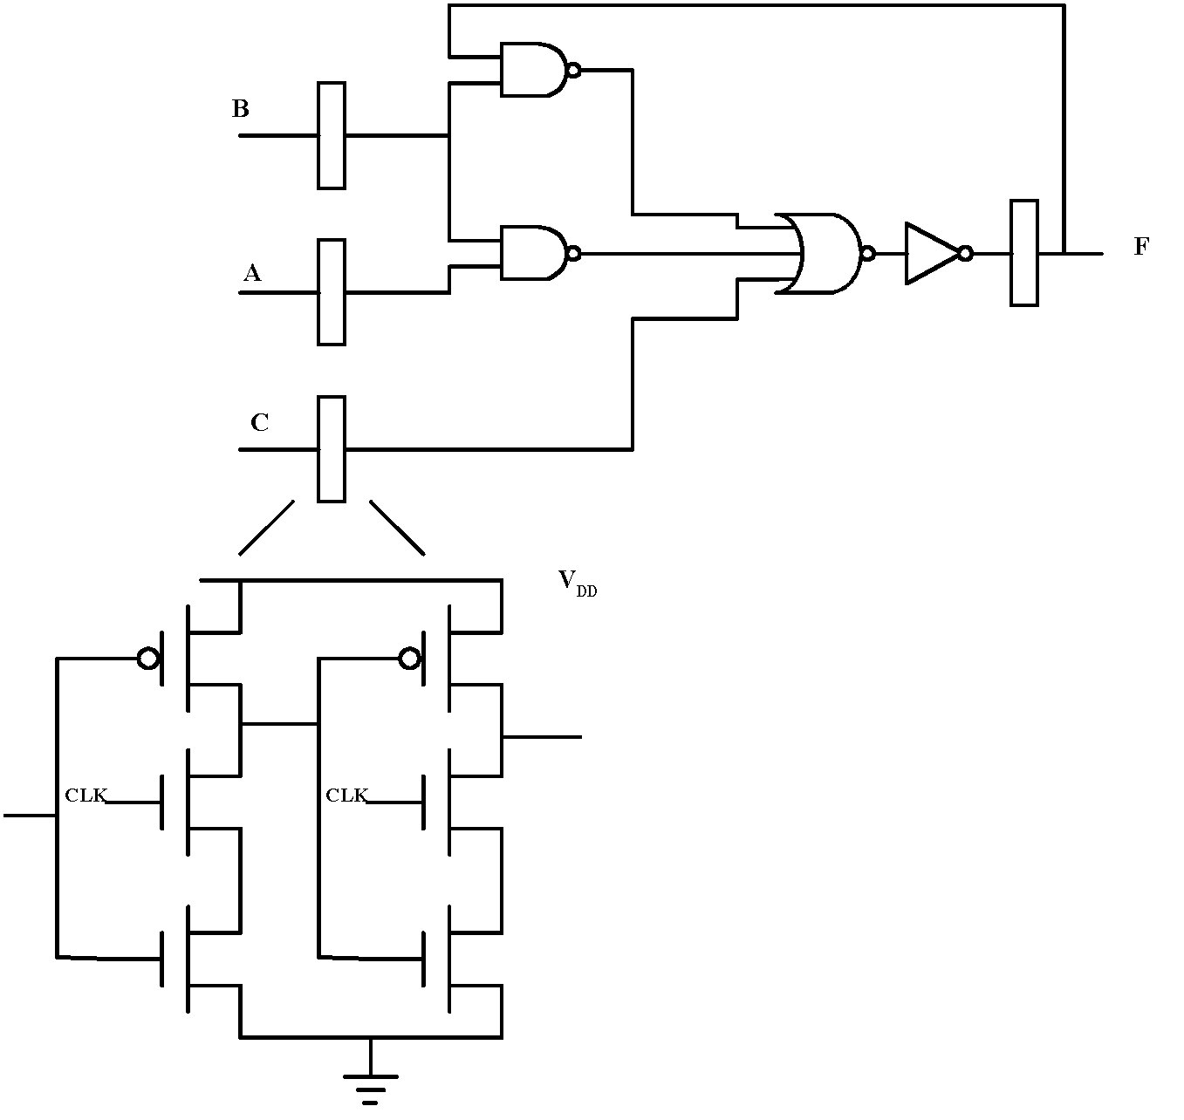

Minimum clock period:
T_{min} = t_{preg} + t_{pNAND}+ t_{pNOR}+ t_{pinv} + t_{setup}
TSPCR will not cause a race if clock skew is minimized.

